Modern College of Arts, Science and Commerce, Pune-05

Department of Statistics

M.Sc. II

Date: Submission date:

Practical No. 3

Practical title: Simulation of AR and MA models and Fitting of AR, MA

Models.

Q.1. Simulate the stationary AR (1) process and plot sample autocorrelation function and partial autocorrelation function, φ1 = 0.9 and Zt follows standard normal distribution.

Q.2. Simulate the stationary MA (1) process and plot sample autocorrelation function and partial autocorrelation function, θ1 = - 0.8 and Zt follows standard normal distribution.

Q.3 Simulate the stationary AR (2) process Xt=-0.3Xt-1+0.3Xt-2+Zt follows standard normal distribution.

Q.4 Read the data file AIRPASS.tsm. Fit the ARMA (pq) model also find the values of AICC and BIC and fit AR (2) model...

Q.5 Read the data file DOWJONES.tsm. Fit the AR model using burg estimation and Yule Walker estimation and comment on PACF.

*********************************************************************

Answer-sheet :

>## Q1)

> library(tseries)

> library(forecast)

> set.seed(77)

> sim<-arima.sim(model=list(ar=0.9),n=200)

> plot.ts(sim)

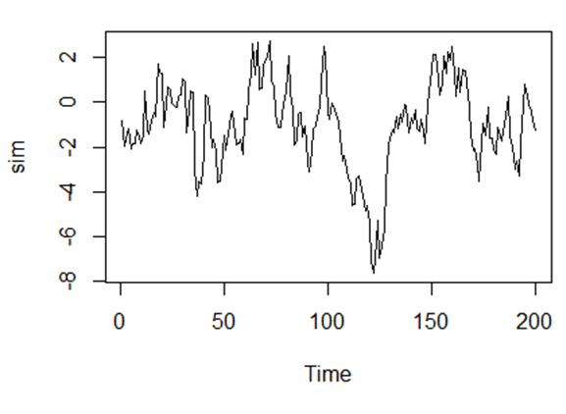

Interpretation: Given is the graph for time series plot of AR (1) process. Where the process is following seasonality.

> acf(sim,type="correlation")

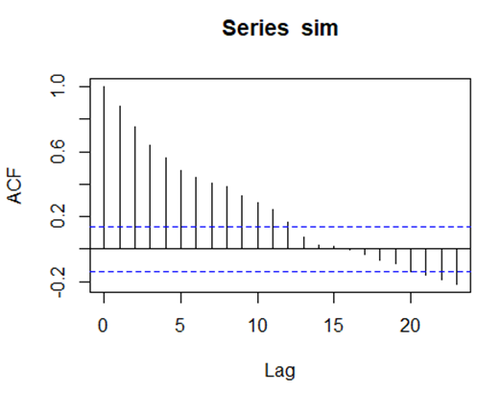

> acf(sim,type="partial")

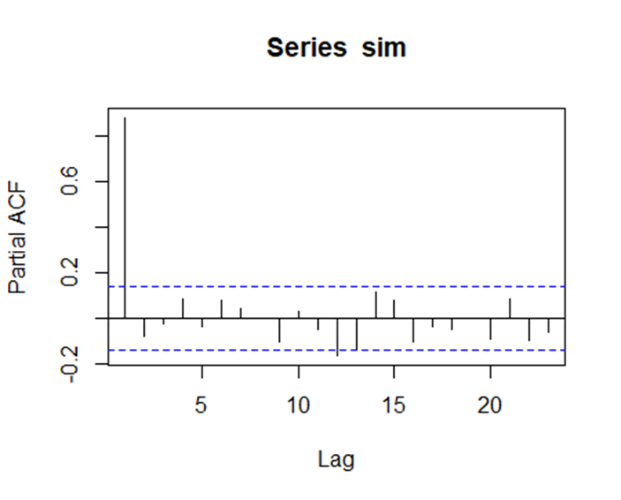

Interpretation: the ACF shows a gradually decreasing trend while PACF cuts immediately after one lag. The graph suggests that an AR (1) model would be appropriate.

> kpss.test(sim)

KPSS Test for Level Stationarity

data: sim

KPSS Level = 0.16737, Truncation lag parameter = 4, p-value = 0.1

Warning message:

In kpss.test(sim) : p-value greater than printed p-value

H0: Process is not stationary

V/s H1: Process is stationary

Here p-value > 0.01 Hence accept H0 and conclude that process is not stationary.

> Box.test(sim,type="Ljung-Box")

Box-Ljung test

data: sim

X-squared = 156.26, df = 1, p-value < 2.2

H0: There is no autocorrelation present ρi = 0

V/s H1: There is autocorrelation present for at least one i ρi ≠ 0

Here p-value < 2.2 we reject H0 that means conclude that, there is autocorrelation present for at least one i

> adf.test(sim,alternative="stationary")

Augmented Dickey-Fuller Test

data: sim

Dickey-Fuller = -2.9169, Lag order = 5, p-value = 0.1921

alternative hypothesis: stationary

H0: Process is not stationary

V/s H1: Process is stationary

Here p-value > 0.01 Hence accept H0 and conclude that process is not stationary.

> ## Differencing to make the process stationary,

> diff_sim=diff(sim,lag=1)

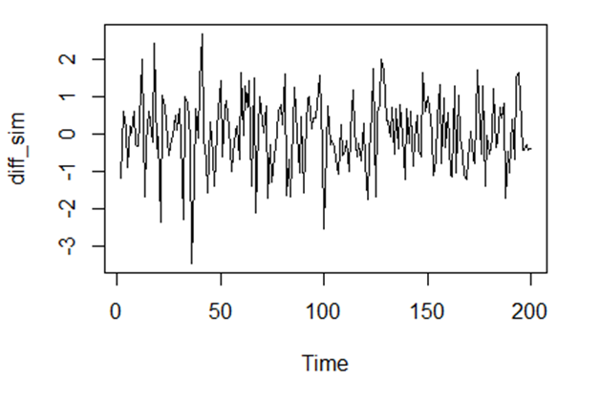> plot.ts(diff_sim)

Interpretation: Given is the Time series plot is for AR (1) process with lag1

> adf.test(diff_sim,alternative="stationary")

Augmented Dickey-Fuller Test

data: diff_sim

Dickey-Fuller = -7.3491, Lag order = 5, p-value = 0.01

alternative hypothesis: stationary

Here p-value =0.01 hence we accept H0 and conclude that process is stationary after

taking lag1

> ## Q2)

> set.seed(87)

> sim<-arima.sim(model=list(ma= -0.8),n=200)

> plot.ts(sim)

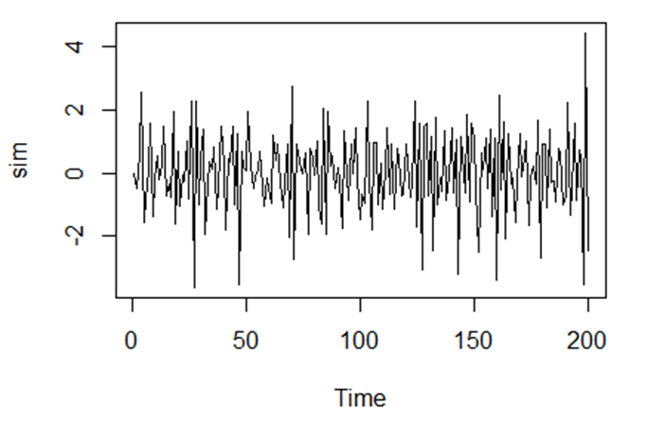

Interpretation: Given is the graph for time series plot of MA (1) process.

>acf(sim,type="correlation")

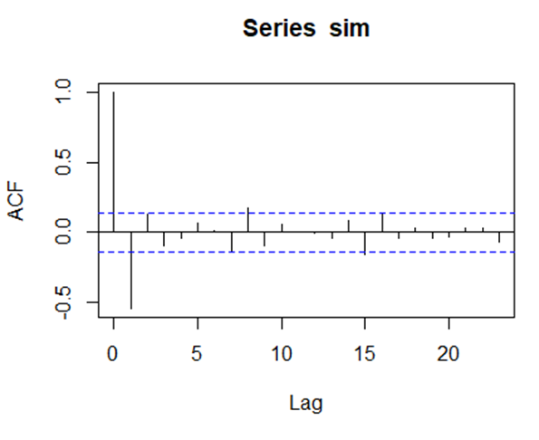

> acf(sim,type="partial")

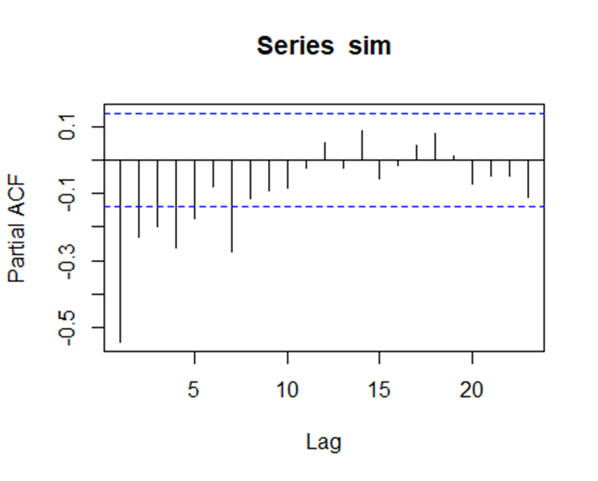

Interpretation: The ACF and PACF plot indicate that an MA (1) model would be appropriate for the time series because ACF cuts after one lag while PACF shows slowly decreasing trend.

> kpss.test(sim)

KPSS Test for Level Stationarity

data: sim

KPSS Level = 0.016113, Truncation lag parameter = 4, p-value = 0.1

Warning message:

In kpss.test(sim) : p-value greater than printed p-value

H0: Process is not stationary

V/s H1: Process is stationary

Here p-value > 0.01 Hence accept H0 and conclude that process is not stationary.

> Box.test(sim,type="Ljung-Box")

Box-Ljung test

data: sim

X-squared = 59.81, df = 1, p-value = 1.044e-14

H0: There is no autocorrelation present ρi = 0

V/s H1: There is autocorrelation present for at least one i ρi ≠ 0

Here p-value < 0.01 we reject H0 that means conclude that, there is autocorrelation present for at least one i

> adf.test(sim,alternative ="stationary")

Augmented Dickey-Fuller Test

data: sim

Dickey-Fuller = -9.1492, Lag order = 5, p-value = 0.01

alternative hypothesis: stationary

Warning message:

In adf.test(sim, alternative = "stationary") :

p-value smaller than printed p-value

H0: Process is not stationary

V/s H1: Process is stationary

Here p-value = 0.01 Hence reject H0 and conclude that time series is stationary.

> ## Q3)

> set.seed(87)

> sim<-arima.sim(model=list(ar=c(-0.3,0.3)),n=200)

> p

lot.ts(sim)

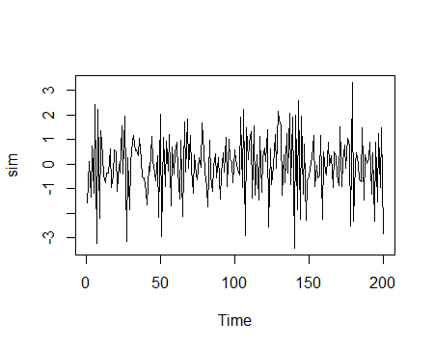

Interpretation: Given is the graph for time series plot of AR (2) process.

>acf(sim,type="correlation")

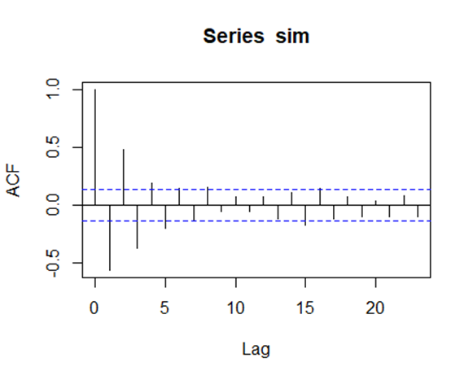

> acf(sim,type="partial")

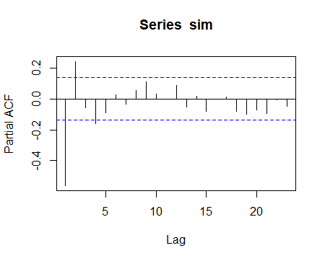

Interpretation: ACF shows slow decay i.e. gradual decrease but PACF is in downward direction at lag1 and after than in upward hence we conclude that AR (2) model would be appropriate for the time series

> kpss.test(sim)

KPSS Test for Level Stationarity

data: sim

KPSS Level = 0.098666, Truncation lag parameter = 4, p-value = 0.1

Warning message:

In kpss.test(sim) : p-value greater than printed p-value

H0: Process is not stationary

V/s H1: Process is stationary

Here p-value > 0.01 Hence accept H0 and conclude that process is not stationary.

> Box.test(sim,type="Ljung-Box")

Box-Ljung test

data: sim

X-squared = 63.704, df = 1, p-value = 1.443e-15

H0: There is no autocorrelation present ρi = 0

V/s H1: There is autocorrelation present for at least one i ρi ≠ 0

Here p-value < 0.01 we reject H0 that means conclude that, there is autocorrelation present for at least one i

> adf.test(sim,alternative ="stationary")

Augmented Dickey-Fuller Test

data: sim

Dickey-Fuller = -6.5128, Lag order = 5, p-value = 0.01

alternative hypothesis: stationary

Warning message:

In adf.test(sim, alternative = "stationary") :

p-value smaller than printed p-value

H0: Process is not stationary

V/s H1: Process is stationary

Here p-value = 0.01 Hence reject H0 and conclude that time series is stationary.

> ## Q4)

> airpass <- read.table("F:/Practicals MSC SY/itsm2000/airpass.tsm", quote="\"", comment.char="")

> View(airpass)

> ap<-ts(airpass)

> plot.ts(ap)

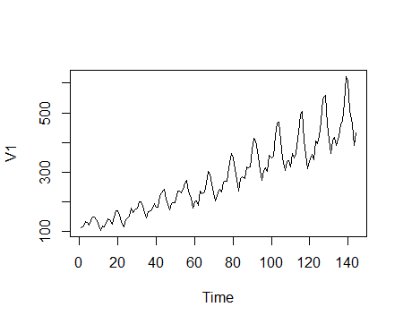

Interpretation: Given is the graph for time series plot of ARMA (pq) process which shows multiplicative upward trend.

> acf(ap,type="correlation")

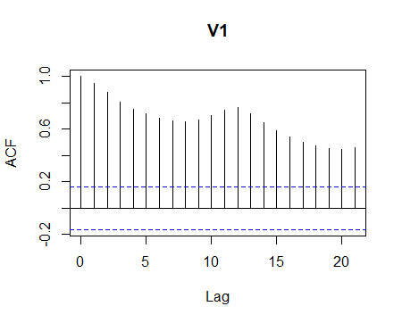

Interpretation: From given ACF plot we can conclude that given process is not stationary.

> acf(ap,type="partial")

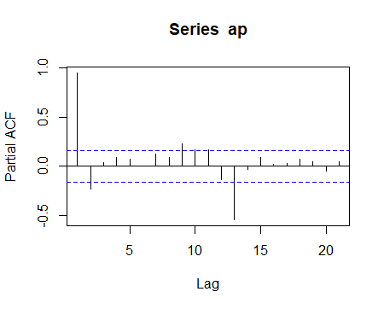

Interpretation: the ACF shows a gradually decreasing trend while PACF cuts immediately after one lag. The graph suggests that an AR (1) model would be appropriate.

> ndiffs(ap)

[1] 1

> m1<-auto.arima(ap)

> m1

Series: ap

ARIMA(4,1,2) with drift

Coefficients:

ar1 ar2 ar3 ar4 ma1 ma2 drift

0.2243 0.3689 -0.2567 -0.2391 -0.0971 -0.8519 2.6809

s.e. 0.1047 0.1147 0.0985 0.0919 0.0866 0.0877 0.1711

sigma^2 estimated as 706.3: log likelihood=-670.07

AIC=1356.15 AICc=1357.22 BIC=1379.85

> m2<-auto.arima(ap,d=0)

> m2

Series: ap

ARIMA(2,0,1) with non-zero mean

Coefficients:

ar1 ar2 ma1 mean

0.4994 0.4311 0.8562 282.4470

s.e. 0.1192 0.1190 0.0765 60.4507

sigma^2 estimated as 969.4: log likelihood=-699.12

AIC=1408.25 AICc=1408.68 BIC=1423.1

> m3<-arima(ap,order=c(2,0,0))

> m3

Call:

arima(x = ap, order = c(2, 0, 0))

Coefficients:

ar1 ar2 intercept

1.2831 -0.3322 280.4696

s.e. 0.0786 0.0792 49.4423

sigma^2 estimated as 995.9: log likelihood = -702.82, aic = 1413.64

> ## Q5)

> dowj <- read.table("F:/Practicals MSC SY/itsm2000/dowj.tsm", quote="\"", comment.char="")

> View(dowj)

> d=ts(dowj)

> plot.ts(d)

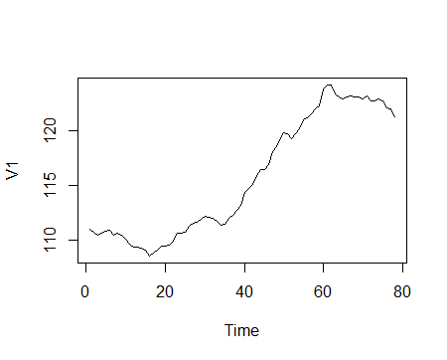

Interpretation: From lag 20 to 60 graph is showing upward trend but after 60 it is going downward.

> acf(d,type="correlation")

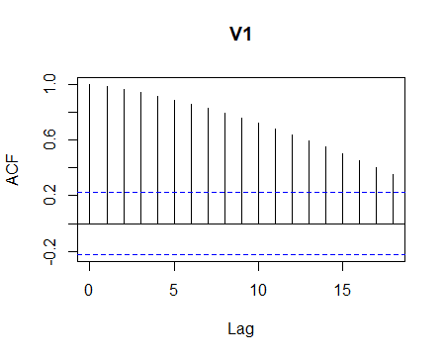

> acf(d,type="partial")

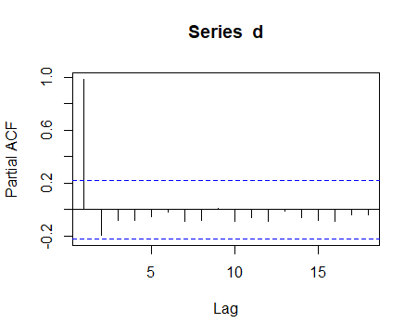

Interpretation: the ACF shows a gradually decreasing trend while PACF cuts immediately after one lag. The graph suggests that an AR (1) model would be appropriate.

> ##differencing is one of the transformations is used on the data to remove seasonality or trend in the data and to make it stationary.

> ndiffs(d)

[1] 1

> d1=diff(d,lag=1)

> acf(d1,type="correlation")

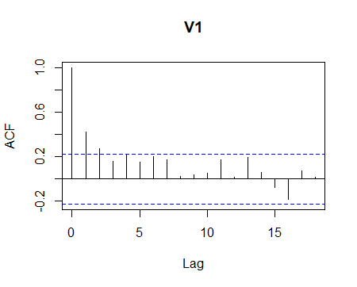

Interpretation: From given ACF plot we can conclude that given process is stationary.

. > acf(d1,type="partial")

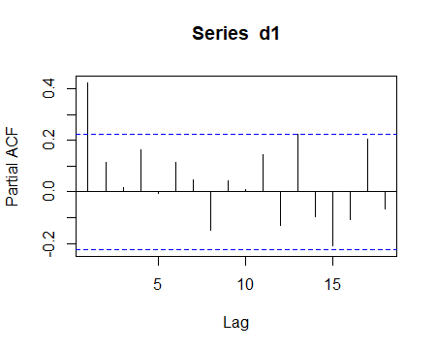

Interpretation: the ACF shows a gradually decreasing trend while PACF cuts immediately after one lag. The graph suggests that an AR (1) model would be appropriate.

> plot.ts(d1)

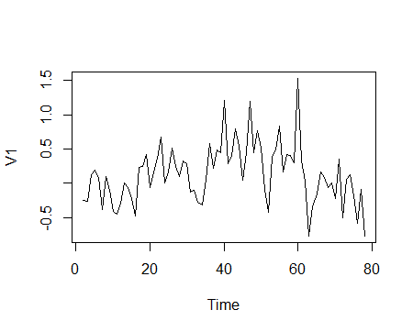

Interpretation: This is time series plot for given data having lag 1 which shows seasonality

> m1<-ar(d1,method="burg")

> m1

Call:

ar(x = d1, method = "burg")

Coefficients:

1

0.4371

Order selected 1 sigma^2 estimated as 0.1455

> m2<-ar(d1,method="yule-walker")

> m2

Call:

ar(x = d1, method = "yule-walker")

Coefficients:

1

0.4219

Order selected 1 sigma^2 estimated as 0.1518

> m3<-auto.arima(d)

> m3

Series: d

ARIMA(1,1,1)

Coefficients:

ar1 ma1

0.8510 -0.5263

s.e. 0.1383 0.2548

sigma^2 estimated as 0.1474: log likelihood=-34.69

AIC=75.38 AICc=75.71 BIC=82.41